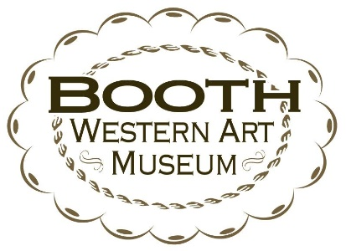
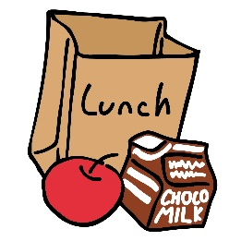
Café Student Group
Lunch Selection Menu

Fax order to: 770-387-1319
Email / Attention to: Debra Abernathy DebraA@boothmuseum.org
Booth Café
Café phone #: 770-387-1300 ext. 7256

Please provide the following information:

Your name:
Contact number:
School name:
Date visiting:
Today’s date:
(Remit at least 7 days prior)
Please circle drink choice: Lemonade or Kool Aid
Total # of lunches:_______________ (10 LUNCH MINIMUM)
Option Totals: (1)_________ (2A)__________ (2B)__________ (3)__________ (4)__________ (5)__________
(4 order pizza minimum) Pizza 1 Hot Dog 2 Hot Dog Ham Turkey PB&J
6.50 5.00 6.50 5.00 5.00 5.00

- Place your order at least one week (7 days) in advance. Once order has been placed you may add but cannot reduce numbers.

- Call to confirm your order at least one week (7 days) in advance.

- 7% Sales Tax will be added if your “Sales & Use Tax Certificate of Exemption” is not accompanied with your order.

- 7% Sales Tax will be added to schools outside of Georgia. We cannot accept out-of-state certificates.

*Must use the attached cover sheet to place your order.

Option (1) - $6.50pp:
- 2 lg. slices of cheese pizza per person
- Chips
- Chocolate Chip Cookie
- Lemonade or Kool Aid included
Option (2A) – 1 hot dog $5.00pp
Option (2B) – 2 hot dogs $6.50pp:
- Hot Dog
- Chips
- Chocolate Chip Cookie
- Lemonade or Kool Aid included
Option (3) - $5.00pp:
- Ham Sandwich
- Chips
- Chocolate Chip Cookie
- Lemonade or Kool Aid included
Option (4) – $5.00pp:
- Turkey Sandwich
- Chips
- Chocolate Chip Cookie
- Lemonade or Kool Aid included
Option (5) – 5.00pp:
- Peanut Butter & Jelly Sandwich
- Chips
- Chocolate Chip Cookie
- Lemonade or Kool Aid included

